**CHAPTER 3: METHODOLOGY**

**3.2 Research Paradigm**

This project will base Object Oriented Analysis Design (OOAD) since it will give a more user-friendly interface as compared to Structure System Analysis Design (SSAD) and will give more accessible for improvements and maintenance. The risk of using OOAD is low, and reusability is also high (madhurihammad, 2023) as compared to SSAD. With OOAD the project scalability will be greatly improved and enhanced in its entirety.

**3.3 Methodology**

This project is using extreme programming as its methodology which is under agile that is classified adaptive. Extreme programing is suitable for this project as it emphasizes (team, n.d.)on communication by nature which gives the users a freer space to share their reviews on how the system works for them as their satisfaction is top priority. It also emphasizes simplicity as the system this project aims to makes is one that will be used by people of all walks of life and the simpler it will be the better people will be able to use it and boost their confidence in water transport (altexsoft, 2021).

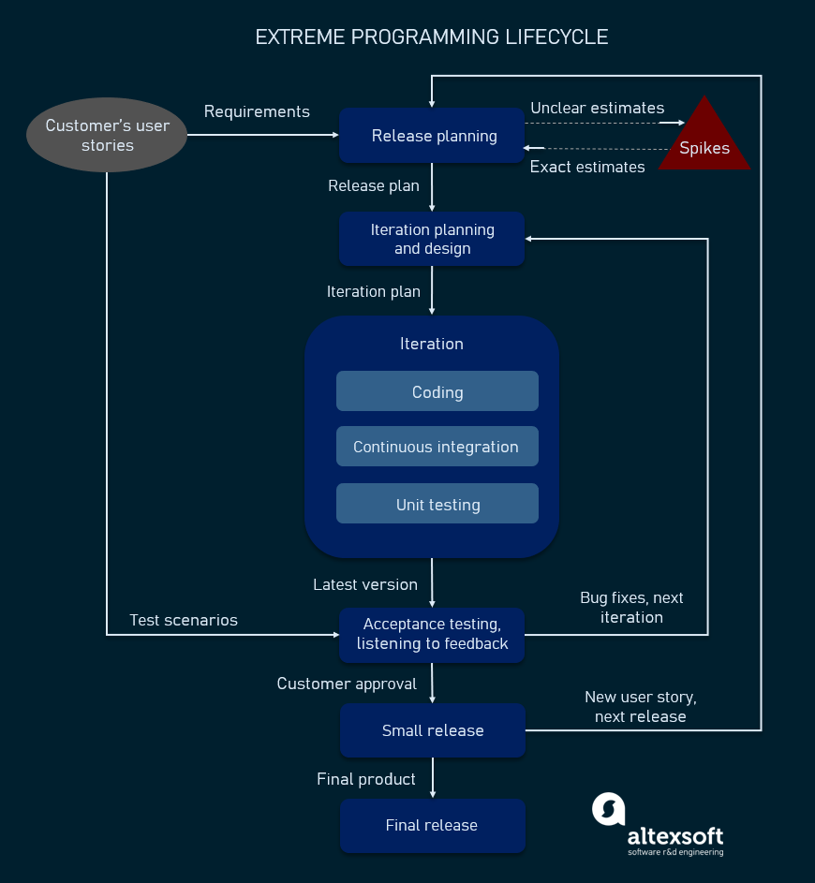

The project is based on people lacking to believe in the use of ferries as a means of safe and reliable transport. Based on journals and reports acquired there were gaps that this project attempts to solve, functional and non-functional requirements were developed with those of high priority and those that provide business value as the first to be released and others following soon after as they were marked as development tasks. The data collected from the reports and journals was used to ensure that customer satisfaction is met and as a basis in development of the proposed system.

With the use of case studies as the research approach implement in this project OOAD was the methodology used to draw designs and develop the solution for the project. ***A use case diagram is going to be used to illustrate how the system will work as it gives a clear outlook of what the exact functions of each of the stakeholders’ functions are in the system.***

The system being built is a web application since it provides people with a more accessible way to be able to interact with the ferry service at the comfort of their homes and it’s all possible with internet access. The system uses HTML/CSS and Java script in front end development, Java and PHP in back-end development and MySQL in database management. These are the tools which will be used in the development of the system since they are the most suitable for each of the sections as they give the front end a more visually appealing and ensure that the system appears to be as simple as possible to favor all type of users. For the back end it will ensure the system is able to run as a web application and ensure that any date input to the system is either directed to the database for storage, hashed out for security purposes and input limits on the input space to make sure that the system works at optimum levels. MySQL will e3nsure proper storage and retrieval of stored data since the system will use this frequently in checking through booked spots on the ferry among many more. The most preferred programming language is Java which is object oriented in nature and will work in NetBeans as its suitable environment. The project will also use VS Code and Xampp as supporting IDES to ensure the system is running to its optimum level. Extreme programing will ensure that the code is refactored and kept as simple and maintainable as much as possible.

These languages and IDES give a more manageable space and are easy to support the proposed system as with pair programming makes it ease to provide support to always ensure a good job which in turn will lead to good results. This approach will reduce the rate of overworking as there is no specialization, but everyone is responsible for the code, hence anyone can remove a part of it if they see it being a liability to the system. Once this is done, there will be a person who will simulate the end process before the user to check if it is correct. Unit testing will be done to check if each part in the system functions as intended.